

Dr. Chad, Bowen inc.
2023-10-04
Dr. Bowen
8358 Claudia Mission Apt. 708, Maxton, AK 93875
Phone: 1120380260
Fax: 1740095362

Re: Laura, Cruz
PHN: 6686874286
Birthdate: 11-May-1952
Address: 803 Joshua Alley Suite 274, New Kurtbury, AR 41222
Patient number: 5746383587

To Whom It May Concern:

This is a medical letter to state the above patient is pregnant with expected delivery date of 15-Mar-2025. Hoping this information is satisfactory for your requirements.

Thank you.

Sincerely,
Dr. Chad, Bowen
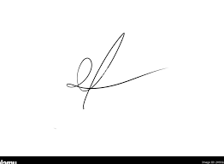
FRCS© NCMP
Clinical Assistant Professor, UBC
Department of Obstetrics and Gynecology SMH

